
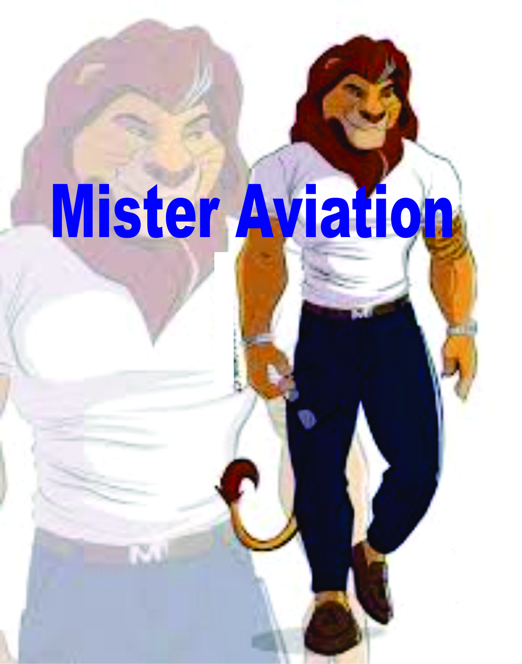
MISTER INDIA, AVIATION
REGISTRATION FOR VIRTUAL SHORTLISTING
Next round selection will be based on maximum likes
and comments on our social media links

Org. by Aviation Games, India, a division of BIAG www.biagindia.org
Planner & designer Bhartiyam www.bhartiymsports.com
DA-18,VikasMarg, Delhi,India

This is an open event for INDIAN MALE above 18 years of age
The Mister India pageant, competition is the matter of pride for every male of India, as this is a short listing process for World event of Aviation industry in Universe. In India this is hosting first time with a great choreographers, Judges and organisation along with designer(s) related to Fashion, jeweler, accessories & dress with hair & makeup.

Referred by:Click here to enter text.Mobile:Click here to enter text.

Participant’s Name (First, Middle, Last):Click here to enter text.

Permanent Citizenship:Click here to enter text.

Alternative Citizenship/ Authority (Attach proof):Click here to enter text.

Your Email Id:Click here to enter text.

Face Book Id:Click here to enter text.Instagram Id:Click here to enter text.
Linkedin Id:Click here to enter text.Skype Id:Click here to enter text.
Other social media:Click here to enter text.

Mobile with WhatsApp/IMO/Viber/ Botim (1):Click here to enter text.Mobile (2):Click here to enter text.

Residential number with ISD & STD code:Click here to enter text.
Occupation: Click here to enter text.Organization:Click here to enter text.
Designation:Click here to enter text.

____________________________________________________________________________________

PHYSICAL ATRIBUTE:

Height (Inches): Click here to enter text.Weight (in kilograms):Click here to enter text.

VITAL STATISTICS (IN INCHES):Click here to enter text.

DOB:Click here to enter a date.Bust:Click here to enter text.Waist/Hips:Click here to enter text.

UPLOAD: Total 3 Photos

Photo 01: In Sari(File size not more than 2.0 MB)CLOSE UP

Photo 02: MID SHOT

Photo 03: FULL LENGTH

UPLOAD YOUR VIDEOs:

You can send video shall not be more than 60 seconds long, at a time.

Video Format: mp4, mpeg, 3gp, maximum size 5.0 mb(max):

Your video shall clearly and completely describe about you, your city, your working profile.

Share your interest for participating.

Click here to enter text.

Specify future goals with this International project for Indians living globally, along-with your performance to understand all about you & short-list.

Click here to enter text.
DESCRIBE YOURSELF in an audio clip in Hindi/ English.
EDUCATION
1.SCHOOL
2. GRADUATION
3.POST GRADUATION
4. OTHER CERTIFICATION
HOBBIES/ INTERESTS:
Click here to enter text.

FULL FAMILY DETAIL (Blood relation only) WITH OCCUPATION & IDENTITY:
Click here to enter text.

HAVE YOU PARTICIPATED IN ANY FASHION /PERSONALITY SHOW/PAGEANT SHOW ETC. BEFORE? Specify with dates, year, location and result
Click here to enter text.

After short listing, you may get participation in many titles ie Mr. Photogenic, Mr. Skin, Ms. Personality etc.

Participation Fee for short- listing round

From Educational sector INRs 850/- Per Video clip For 58 SEC

Education sector Outside India USD15

Other Individual INRS. @1250/- per Video clip FOR 58 SEC.

Living /working out of INDIA Fee US$40 per Video clip FOR 58 SEC.

Corporate entry with Letter from org. 3000/- & NRI /OCI USD60

you may send more videos to get more likes after first listing with extra payment

please note, there is No refund policy, Pay to

BHARTIYAM,
Punjab National Bank, Delhi NCR
A/c no. 4718000 1000 82580,
IFS Code- PUNB0471800

Remark in payment (MR. Aviation)

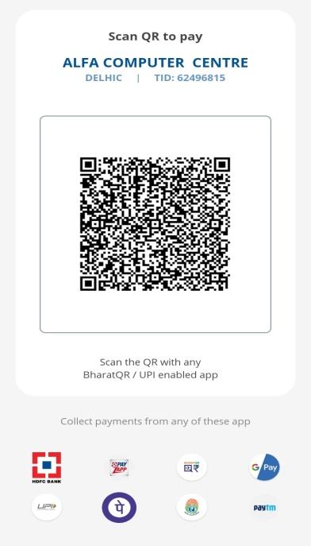

Check before sending your receipt + videos + Attached ID+ BUSINESS CARD

GENERAL information & CRITERIA

You may represent any country to get participation (Attach photo & address ID).

Height (Min. 4’.8"), 18 and above of age (on the day of physical appearances)

MR. Title- Any MALE (Can be single or married & with no age limit)

Official languages: Hindi / English

Total Prizes for male categories are :

Finally all 4 top winners of all segments may get assignments, endorsements & advertising films and others

Worth USD2,000

Terms & Conditions, which is also part of declaration;
- Final event may happen on physical basis, AGI also planning regional events in different cities of India and will intimate to participants, Keep note participation and winning in regional chapter does not effect on your participation at National virtual selection but winner of regional events may get extra points, which may help to get more marks during physical National, which may happen in 2nd - 3rd quarter of next year, ☐
- At national level, Only the short-listed candidate may be informed further. We are also planning Offline event at some countries to cover NRI/ OCI/ PIO in Singapore, Dubai, Chicago, NewYork, UK & some other part in the world, keep note short listing in an International arena would be treated as part of short listing of Mr. World & Universe, on same way for Miss, Mrs. & Lady Positive plus. World Aviation event may happen in the end of the year of 2022 at Uganda in Africa or Singapore. ☐
- Filling form does not mean that you are selected. Wait for the short-listed announcement on our website. ☐
- First 10 will get titles of various segment of Mr. Aviation project (Country wise). ☐
- Different title winners may get assignment, endorsement etc. through our platform and you have to fill the MOU separately after the final project. ☐
- The applicant must agree to abide by all the rules, as changed from time to time by the Organizers. ☐
- The applicant should be above 18 years of age as on the day of the physical event. ☐
- The applicant uses the prefix 'MR' (Single OR Married). ☐
- We may generate your participation code after getting video with all docs.. ☐
- The applicant should be naturally born by a Male. ☐
- The applicant should hold a valid country passport to represent Country/ Continent.. ☐
- The applicant or the applicant's immediate family should not be related to any person employed by the organizers, contest sponsors and their sub - contractors, or any of the judges as informed to the applicant at any stage. In case of such a relation, the applicant must disclose the same immediately. ☐
- The applicant can be under commercial contract with anyone but he shall be available to the organizer as per need of the contest/assignment at all times, after filling in this form and till the results are declared to the general public. ☐
- The Organizers are not responsible for any delays or non-receipt of applications on any account and for any reason whatsoever. ☐
- If an applicant had won the prestigious pageant’s award previously, inform us to be able to get some additional marks for the short-listing rounds. ☐
- The applicant will have to participate in a disciplined and diligent manner throughout as per the given schedule. ☐
- The Organizers are not responsible if the sponsors do not give good prizes as promised by them☐
- The Organizers are not responsible for any loss or physical injury that occurs to the applicant on account of their participation in the event. The applicant will participate at his own risk and can have no claim against the organizer or any other group, in any regard. ☐
- Incorrect information will result in disqualification, whether discovered prior to, during or after participation / short-listing and the applicant may also have to bear financial punishment. ☐
- The decision of the Judges /Jury will be final in all cases. ☐
- Only persons of good health, sound mind and having no medical history of any mental illness and having a good moral character can participate herein. ☐
- Only the applicant will be allowed inside the designated venue of the short listing & training /grooming. ☐
- The schedules of all part of the sub/events rounds are subject to change and at the discretion of the Organizer. ☐
- The Organizers are not responsible for non-completion / non-occurrence of the event. ☐
- In the event of any dispute, the Organizers decisions are final and binding on the applicant☐
- The courts of NCR have the jurisdiction over all disputes. ☐
ONLY ONE email listing is applicable till end of the event. Next round selection will be based on max. Likes & comments on our social media. There is no requirement for any communication till the virtual round is finished. In-case we need to communicate, our office will send you an email. Please note that every act, step, behaviour etc.of yours towards the event will count and you will get a bonus point towards this.

MR. India Aviation
VIRTUAL SHORTLISTING
Org. by Aviation Games, India, www.biagindia.org
Planner & designer Bhartiyam www.bhartiymsports.com
DA-18,VikasMarg, Delhi,India
This is an open event for INDIAN MALES above 18 years of age

Next round selection based on maximum like/ comment on our social media & judge’s decision
Next round selection based on maximum like and comment on our social media,, We may send you a link to invite likes & comments on your video from your friends, colleagues& family.

DECLARATION

I, have read and understood all terms & conditions for my participation in this contest. I am allowing organisers to use my photos & videos in future project in all good manner to promote Beauty pageant as a sports, I will also abide by all terms & conditions to be permitted for PARTICIPATION, SHORTLISTING and all further steps leading to the final event.By Marking OK,
I agree with all of the above & am bound by the declaration.

☐
MARK OK

☐
Name: Click here to enter text.
☐

Date:Click here to enter a date.

☐
City:Click here to enter text.

☐
Country:Click here to enter text.

☐
Bank Receipt No. dt :Click here to enter text.

☐
Name of bank:Click here to enter text.

☐
Amount:Click here to enter text.

